DATA MINING FINAL TERM PROJECT (CS-634)

OPTION1
SUPERVISED DATA MINING (CLASSIFICATION)

Professor
DR. JASON WANG, NJIT

Sai Sarvani Ippagunta
UCID: si89
email: si89@njit.

OPTION1:

To implement two algorithms (Random Forest and Decision Tree) on same dataset and compare their accuracy.

PREDICTION OF BIKE RENTALS – DECISION TREES AND RANDOM FOREST

Bike Sharing Demand. Below is the URL of dataset:

https://www.kaggle.com/c/bike-sharing-demand

Description of the Data Problem:
Bike sharing systems are a means of renting bicycles where the process of obtaining membership, rental, and bike return is automated via a network of kiosk locations throughout a city. Using these systems, people are able rent a bike from a one location and return it to a different place on an as-needed basis. Currently, there are over 500 bike-sharing programs around the world.
The data generated by these systems makes them attractive for researchers because the duration of travel, departure location, arrival location, and time elapsed is explicitly recorded. Bike sharing systems therefore function as a sensor network, which can be used for studying mobility in a city. In this competition, participants are asked to combine historical usage patterns with weather data in order to forecast bike rental demand in the Capital Bikeshare program in Washington, D.C.
This dataset was provided by Hadi Fanaee Tork using data from Capital Bikeshare.

GOAL:
To predict the total count of bikes rented(class label) during each hour covered by the test set from 20th to the end of the month using the training set from 1st to 19th of the same month with both Random Forest and Decision Tree algorithms and compare their accuracies.

Description of dataset:
We are provided with hourly rental data spanning two years of bikes.
The training set is comprised of the first 19 days of each month of rental data,
while the test set is the 20th to the end of the month.

Total number of instances in Training Dataset: 10887
Total number of instances in Test Dataset: 6494

Class Labels/ Dependent variables:

casual - number of non-registered user rentals initiated
registered - number of registered user rentals initiated
count - number of total rentals

Features/predictors for the dataset:
datetime - hourly date + timestamp
season - 1 = spring, 2 = summer, 3 = fall, 4 = winter
holiday - whether the day is considered a holiday
workingday - whether the day is neither a weekend nor holiday
weather - 1: Clear, Few clouds, Partly cloudy, Partly cloudy
2: Mist + Cloudy, Mist + Broken clouds, Mist + Few clouds, Mist
3: Light Snow, Light Rain + Thunderstorm + Scattered clouds, Light Rain + Scattered clouds
4: Heavy Rain + Ice Pallets + Thunderstorm + Mist, Snow + Fog
temp - temperature in Celsius
atemp - "feels like" temperature in Celsius
humidity - relative humidity
windspeed - wind speed.

EXPLORATORY DATA ANALYSIS AND DATA PREPARATION:
Exploring the dataset and understanding training dataset using initial analysis with box plots.
Screen shots are below in order –

Exploring the structure of the data :
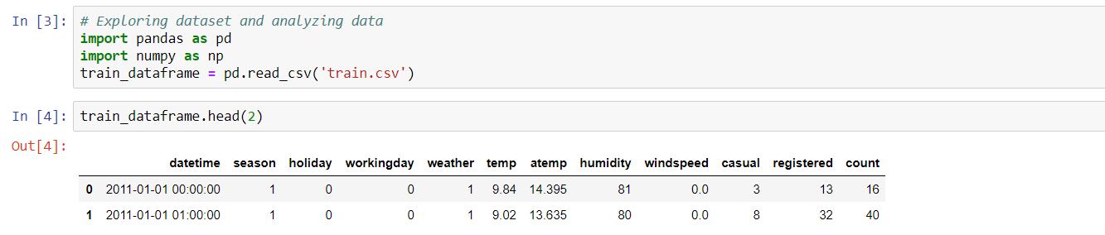

1. Creating a new features in dataset for splitting up datetime like year, month, dayofweek and hour. As they might be interesting features to predict count on.
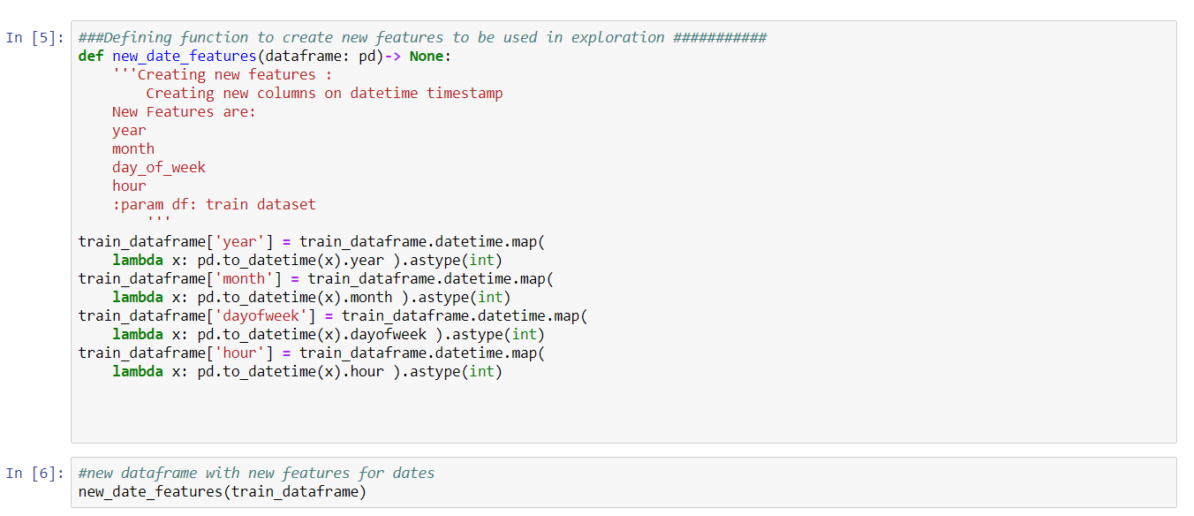

Checking the structure of the data to confirm after adding the additional features

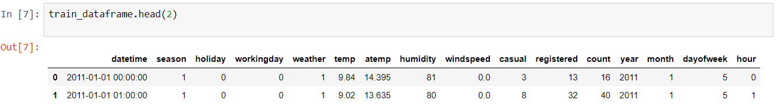

We can see the four additional columns added to the data frame for further analysis.

These additional columns are added to closely monitor the correlation between label and them .

2. Plotting various box plots to understand the count under various conditions.

- Box Plot for all the features
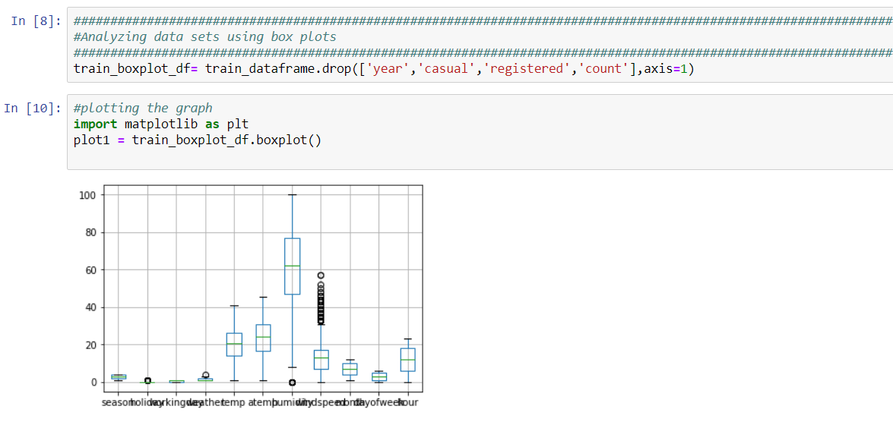

Observation :

- Box Plot for count vs weather :

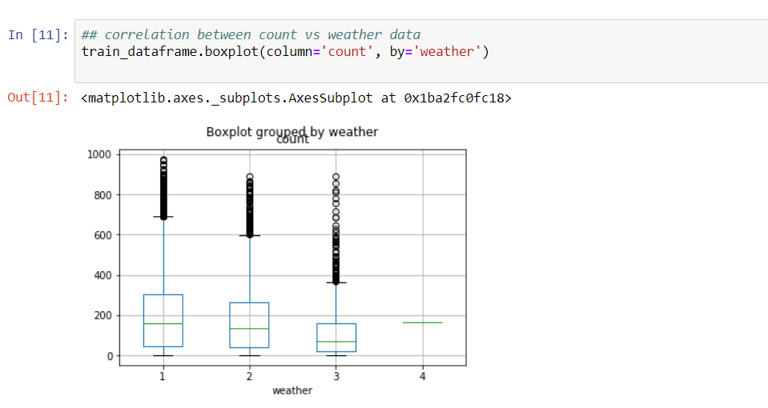
Observation: we can see max, min, average and outliers from the box plot.

- Box plot grouped by hour vs count
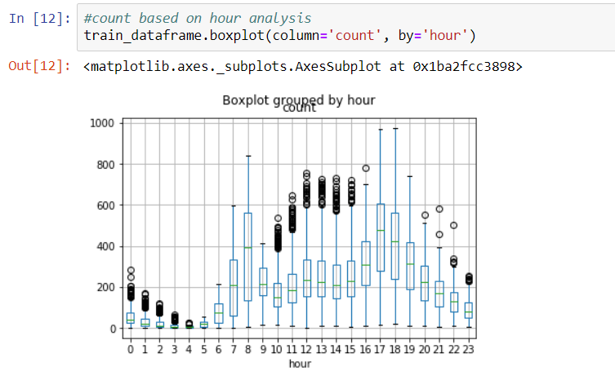
- Boxplots for count vs day of week
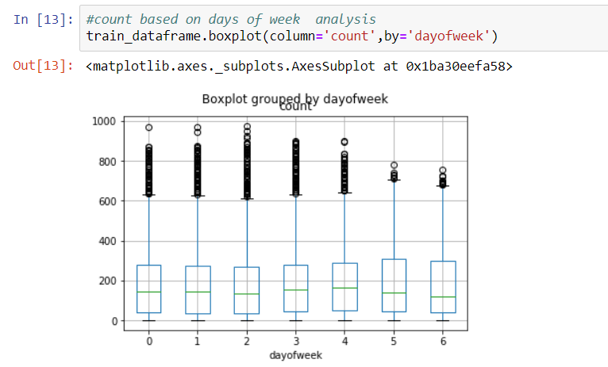
Observation:

Mapping name of day of week to the respective name of week
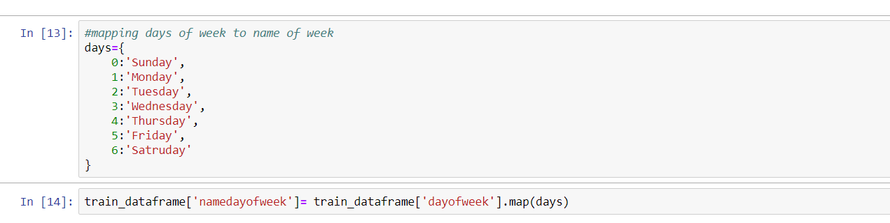

3. CORRELATION MATRIX :

Correlation Matrix determines which features that are positively correlated, negatively correlated and highly correlated. This helps us to identify important features in predicting class label and identify duplicate features (positively correlated ), so that these one of the feature can be removed from the model.

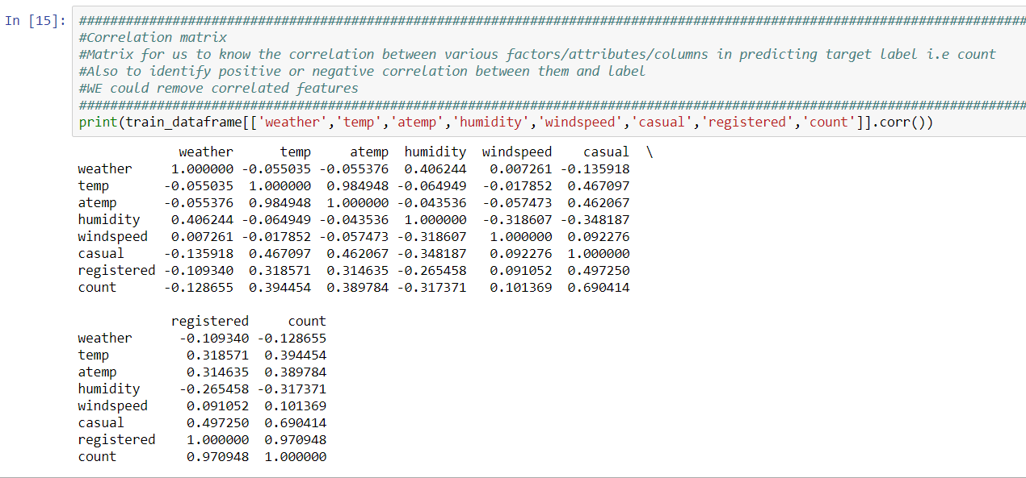

Observation:
- Temp is positively correlated to count
- Temp and atemp are highly correlated , atemp can be eliminated from the dataframe for further analysis since it doest make any change in the correlation . Only one of them can be considered.
- Humidity and count are negatively correlated , so we can assume that more the humid the weather is , the less bike rentals are taken.
- Windspeed is also negatively correlated, hence we may assume that more windspeed less number of rentals.

5. Preparing Test data set:

Creating new features for test dataset that are created for training dataset.

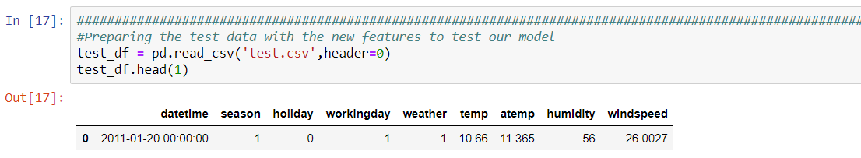

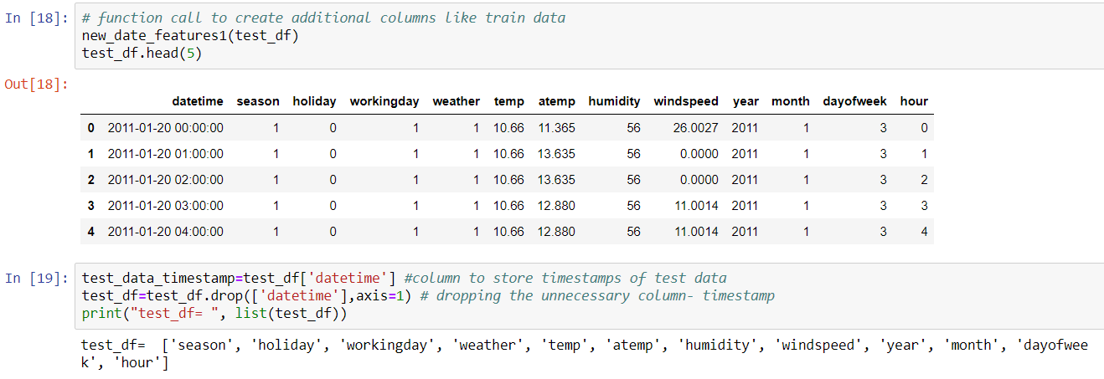
Now the test data set has also the same predictors/independent variables to send to the ML model to predict the lables.

Training your Model:
Training model with Random Forest and Decision tree algorithms on training dataset.
- RandomForestClassifier module is being used from sklearn.ensemble in python with 120 trees. n_estimators are selected with trail and error method.
- DecisionTreeClassifier module is being used from sklearn.tree in python.
Importing Libraries:
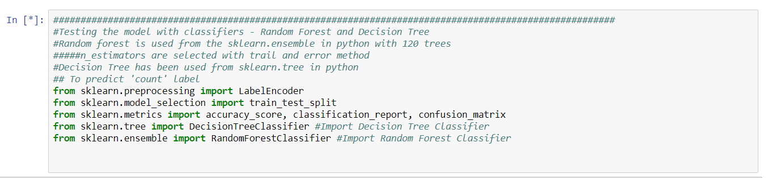
Training the classifiers with training data_set
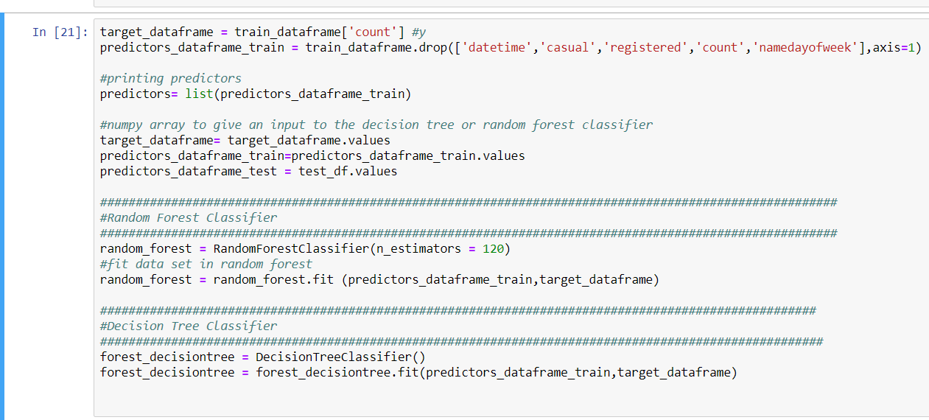
Predicting the count to test data set and saving it to a file:

Once the model is trained, applying the model on test data set to predict the count with both the algorithms and pass those values to two corresponding predictor files and saving it.
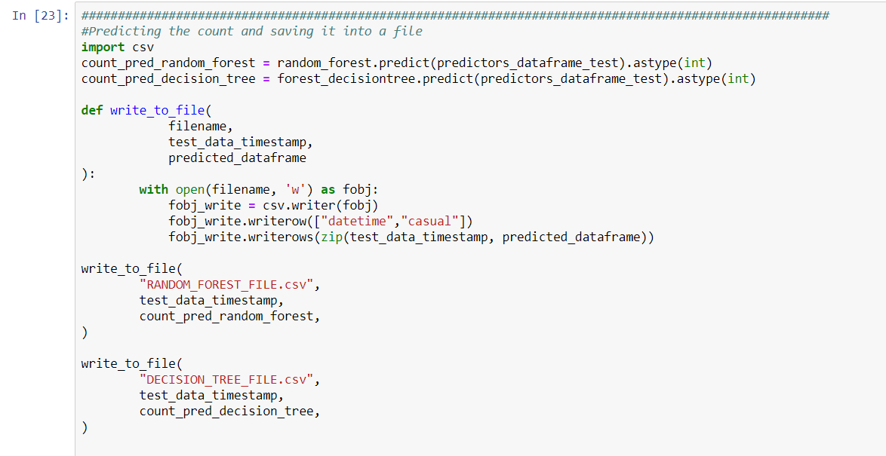

Printing important features extracted from the training data using Randomforest:

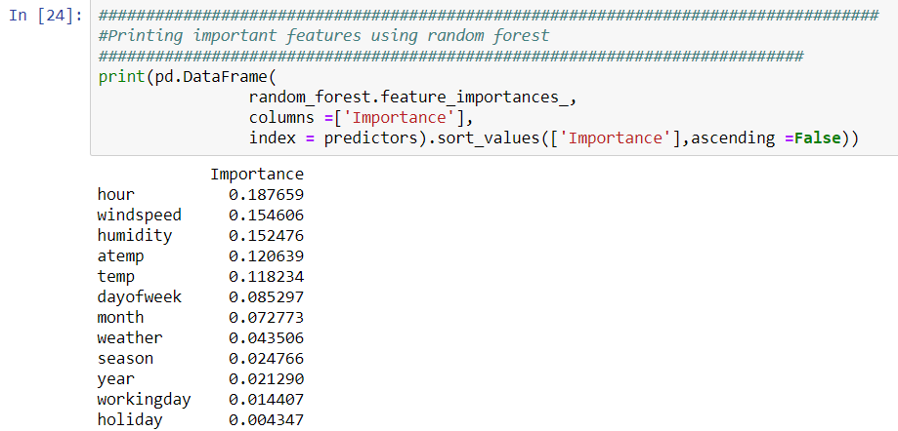

Radom Forest Count predicted: Total records with two columns . A sample of the random forest predicted values data set is shown below :
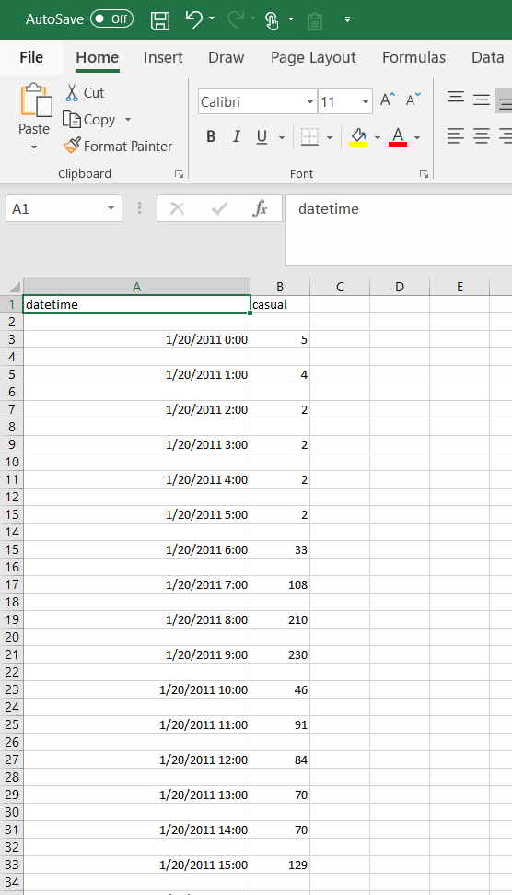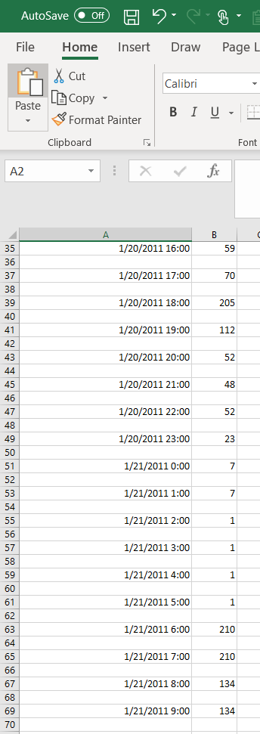

Decision Tree Count predicted:

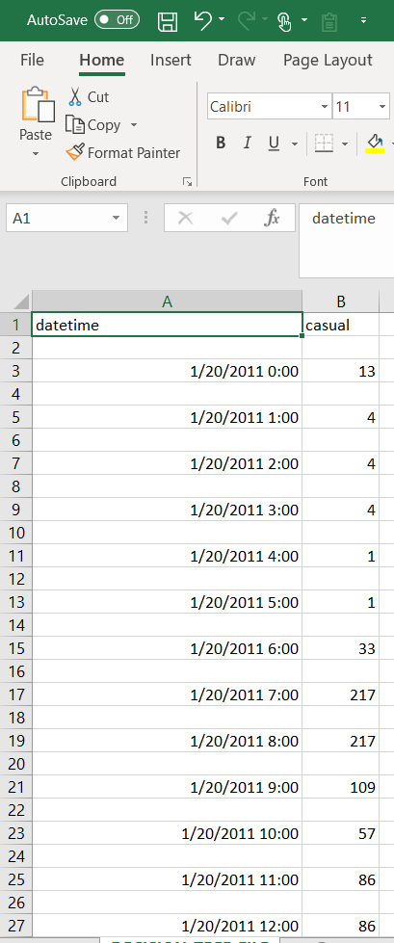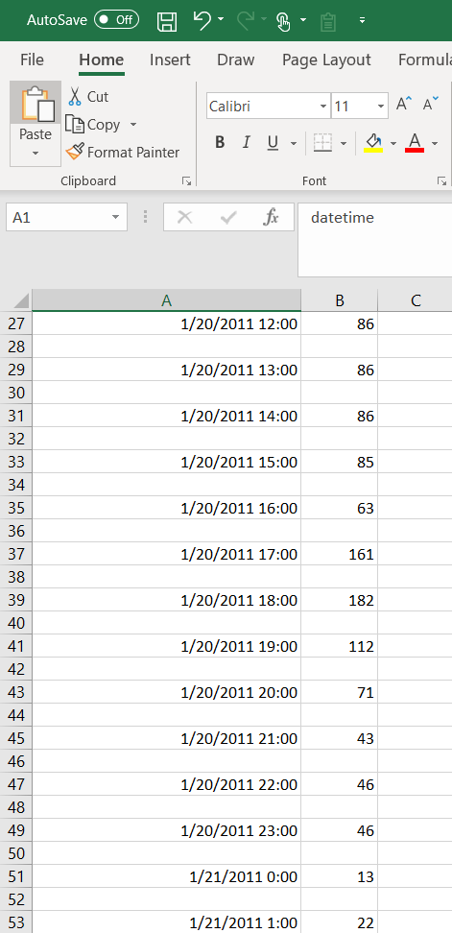

Total 6493 counts have been predicted. Full data set could be found in the github link in the summary at the ending.

Comparison of Random Forest and Decision Trees using Confusion Matrix (validation sets):

Below snippet of code creates validation dataset on spliting trainig into 80% train and 20% validation sets. Now, train your model using new train datasets and apply it on validation dataset. Then obtain a confusion matrix for both Random Forest and Decision Tree algorithms.

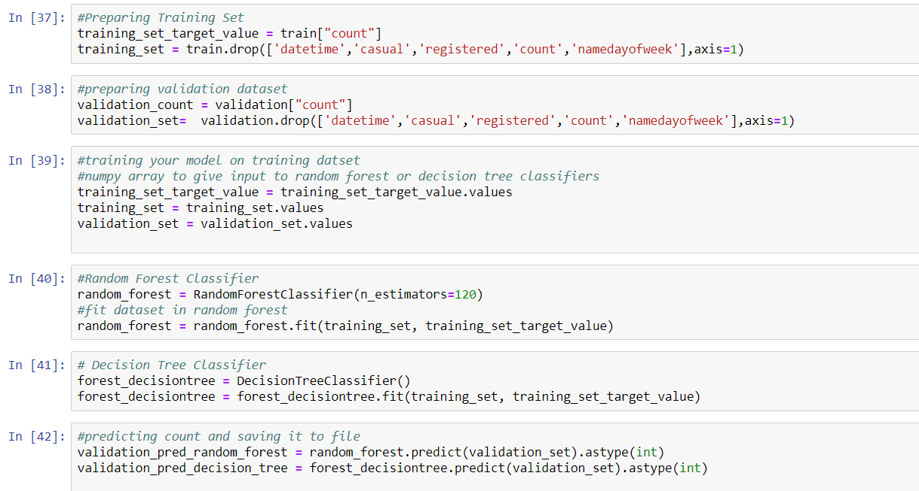
Saving the predicted counts from validation data set
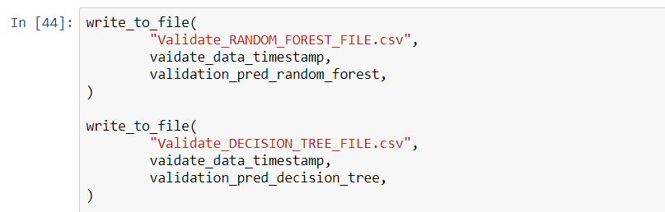

And obtaining the confusion matrix for predicted counts and actual counts of the validaton data sets

Confusion matrix output for RandomForest:

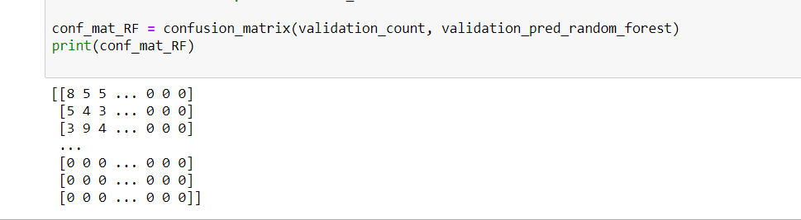

Confusion matrix output for Decision Tree:

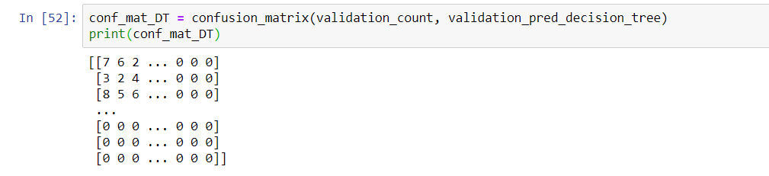

Conclusions:

Applied both RandomForest and Decision Tree classifiers on bike share dataset to predict count. Used validation technique to compare both the models. From the result we have seen Random forest gave us more information compared to decision trees like identifying important features in a dataset.

Tools used : Jupyternotebooks, MS word and MS Excel.
Programming Language and libraries : Python 3.6 with Anaconda Package – Numpy, pandas, matplotlib and scikitlearn.

Full source code of this project can be found at :
Github.com/sarvani92/dataminingcourseproject

References:
Data Set and other references : Kaggle.com, Stackoverflow
Source Code :
Random Forest : sklearn.ensemble

https://github.com/scikit-learn/scikit-learn/blob/7b136e9/sklearn/ensemble/forest.py#L753
Decision Tree : sklearn.tree

https://github.com/scikit-learn/scikit-learn/blob/master/sklearn/tree/tree.py

